Lab task 10.1

Exercise 1

Odd:

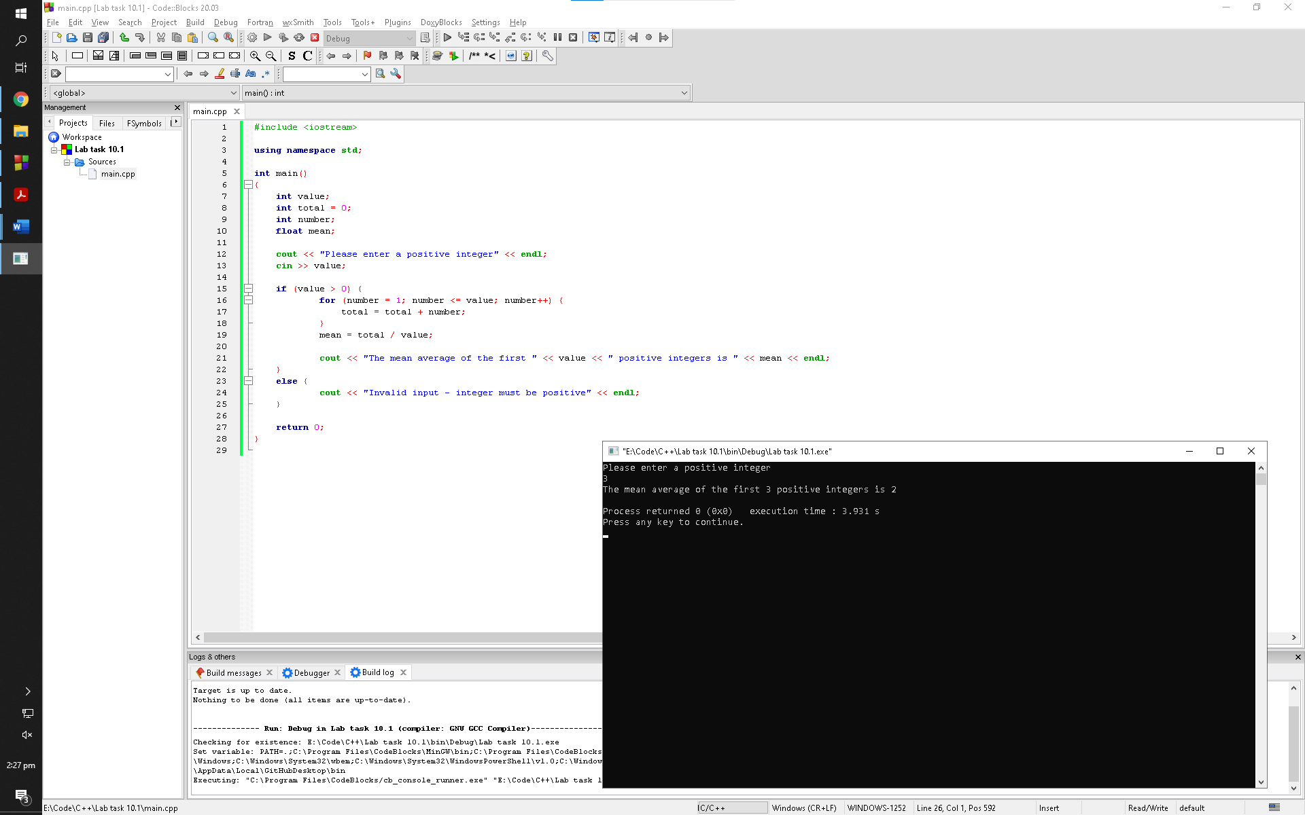

Observation: Typecast operator has no effect if an odd number value in entered. The division part of the mean formulae outputs an integer value which is stored into a float mean variable but since the division is amongst two integers and value stored into the mean variable has to be an integer according to the program. So, the program rounds the value to make it an integer from a float hence making logical sense

Even:

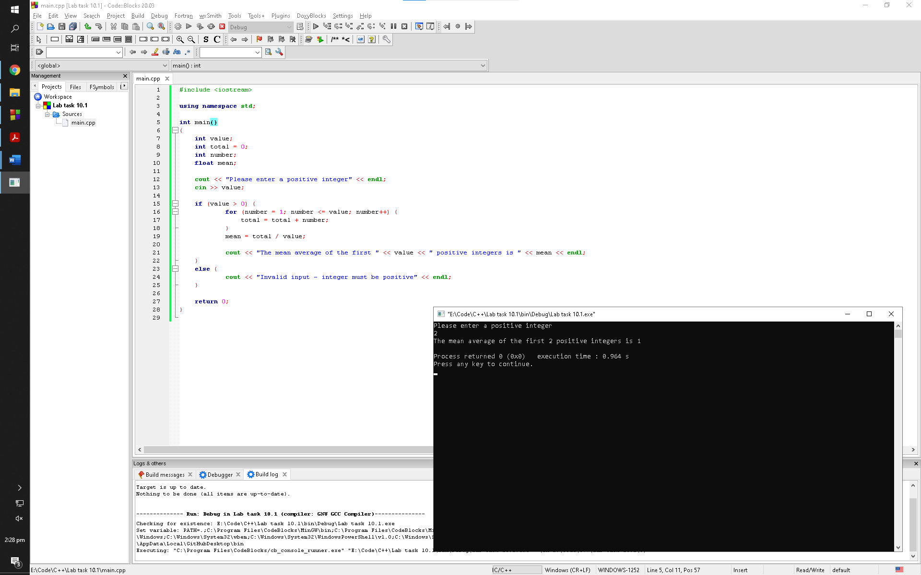

Observation: Typecast operator has an effect if an even number value in entered. The division part of the mean formulae outputs an integer value which is stored into a float mean variable but since the division is amongst two integers and value stored into the mean variable has to be an integer according to the program. So, the program rounds the value to make it an integer from a float hence not making logical sense

Exercise 2

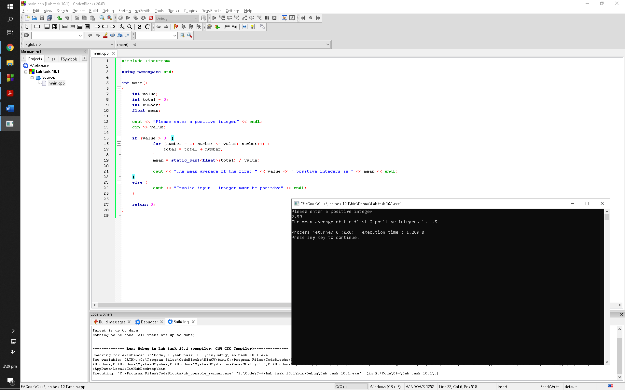

Observation: The program simply ignores the numbers after the decimal when a non-integer positive value is entered into the program. The value of user is being stored in value variable that is initialized as integer which prevents decimal values to be processed hence prompting the user with false answer

Exercise 3

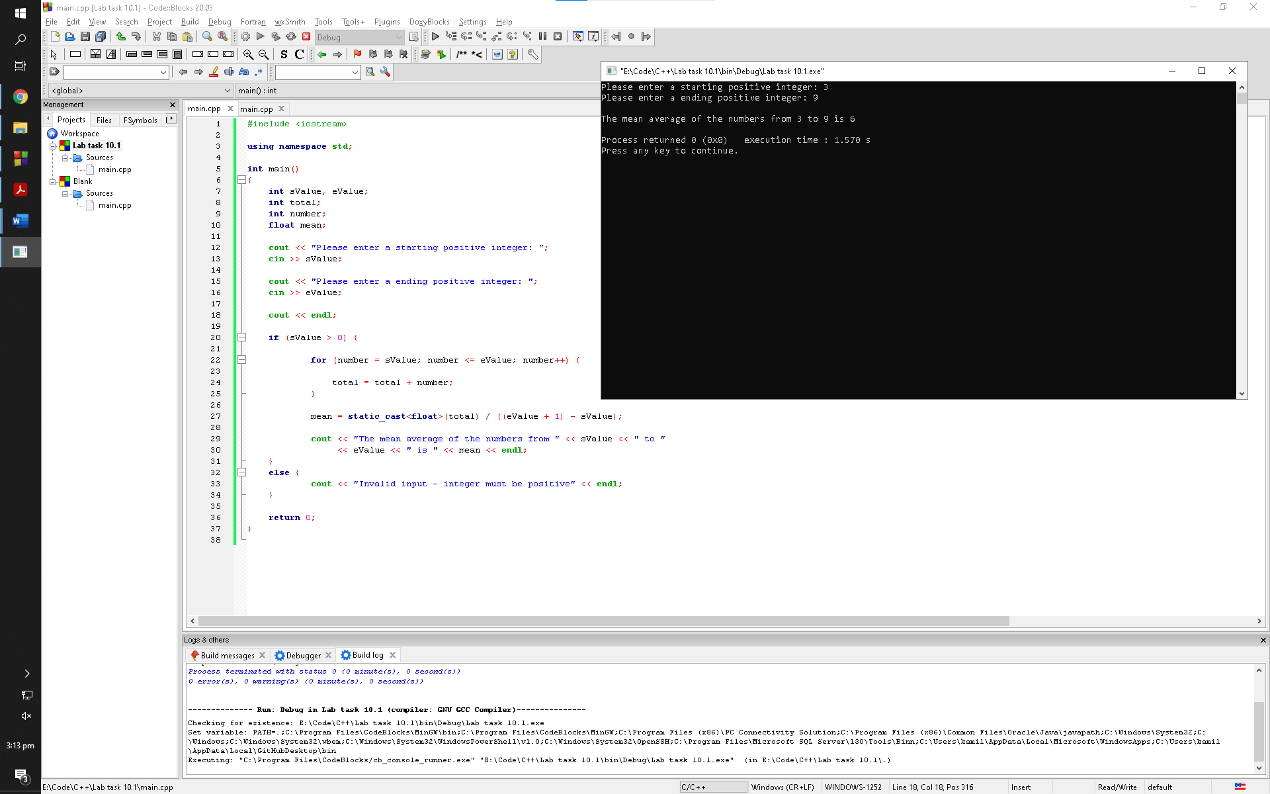

Observation: The program asks the user for the staring number and an ending number. It then adds those numbers and every integer between those numbers. Then, it divides the total with the count of numbers to calculate the mean and then prompts the user with the answer

Lab task 10.2

Exercise 1

Sample run:

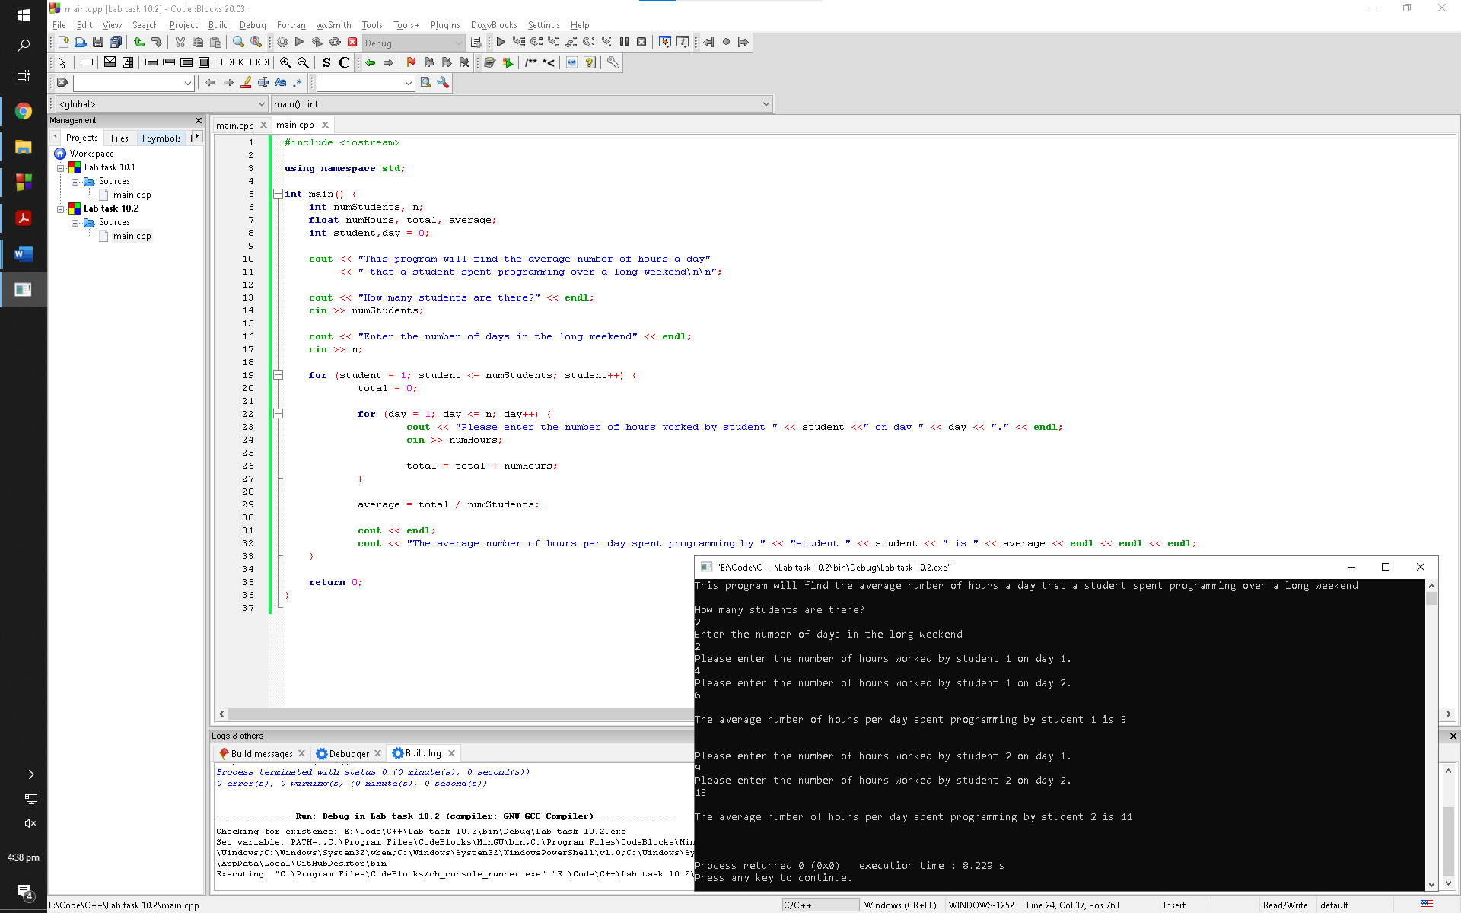

Observation: The program asks the user the number of students and the number of weekends before going into the nested loops. It then keeps rotating in the second for loop until the set requirement is met and then it loops around in the first for loop. It continues to loop around until the set requirement is met in the first loop and then terminates itself

Exercise 2

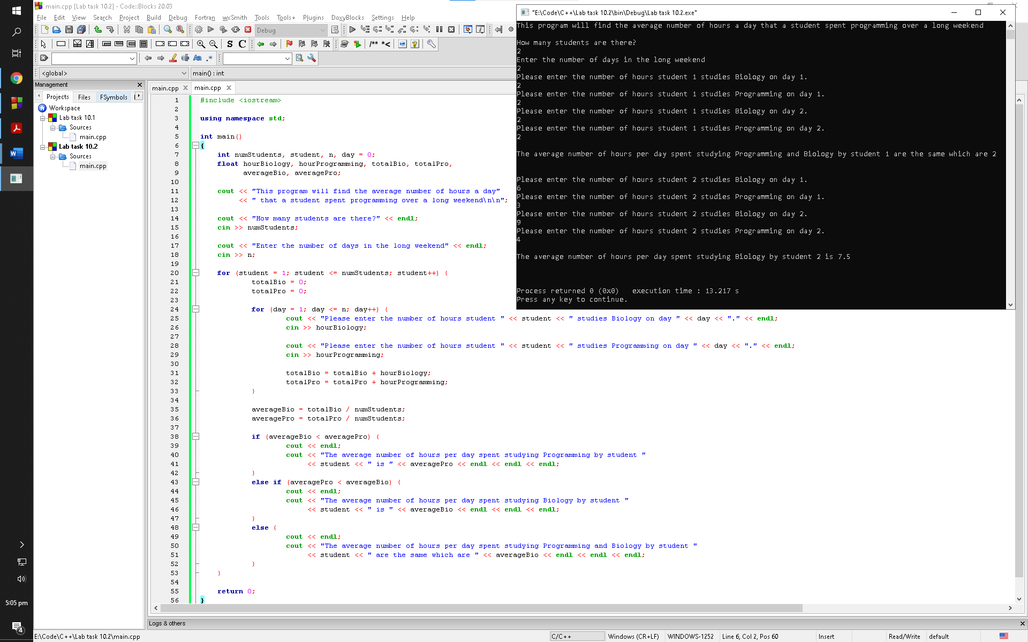

Observation: The program asks the user the number of students and the number of weekends before going into the nested loops. It then keeps rotating in the second for loop until the set requirement is met and then it loops around in the first for loop. It continues to loop around until the set requirement is met in the first loop and then moves on to the if conditions and prints out the statements accordingly

Lab task 10.3

Sample run:

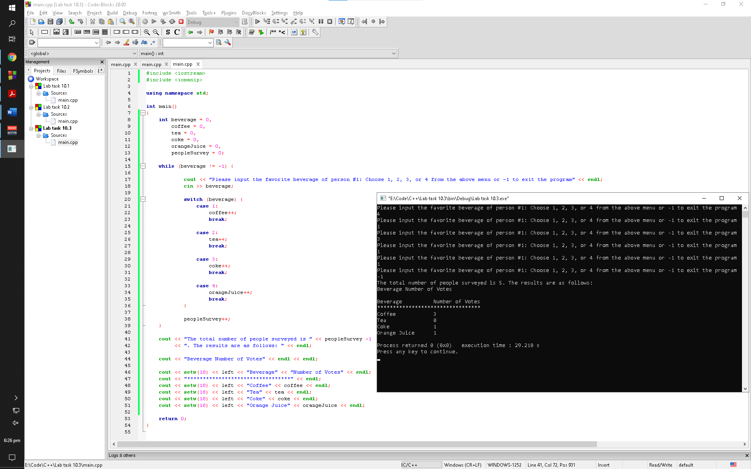

Observation: The program keeps prompting the users to vote for a beverage until one of them enter -1 to abort. Once abort, the program prompts the user with vote casted on what beverages

Lab task 10.4

Sample run 1:

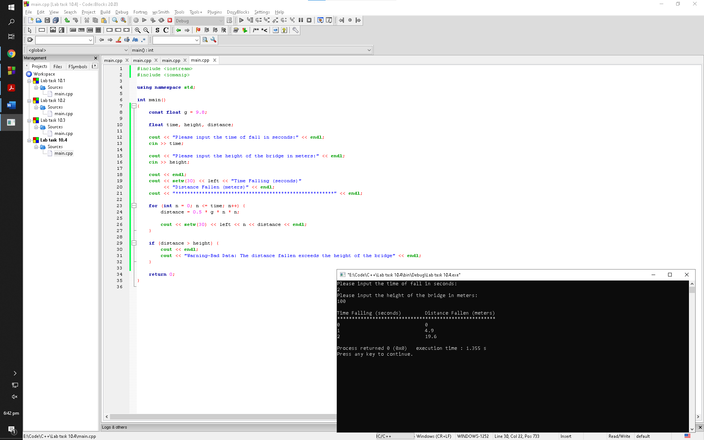

Observation: The program asks the user to enter the height of the bridge along with time the object was falling. The program then prompts the user with distance fallen with increasing seconds with the help of a for loop. Once out of the loop the program terminates since the if statement in not valid in this scenario

Sample run 2:

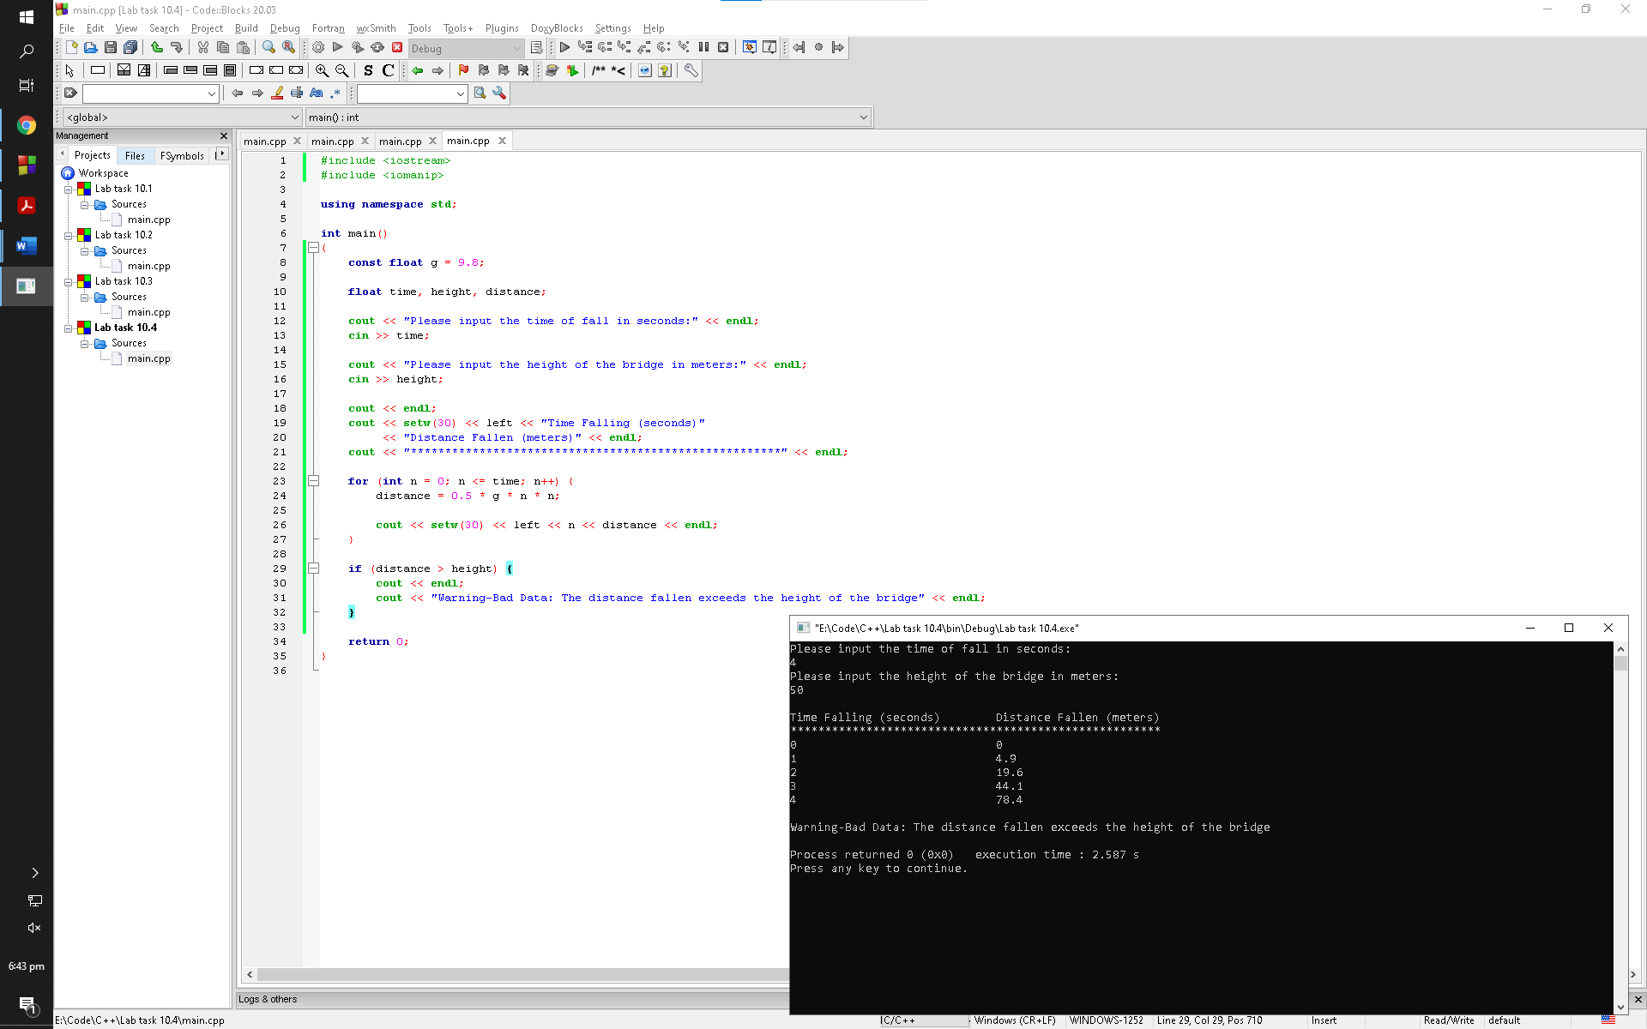

Observation: The program asks the user to enter the height of the bridge along with time the object was falling. The program then prompts the user with distance fallen with increasing seconds with the help of a for loop. Once out of the loop the program terminates since the if statement in not valid in this scenario

Post lab

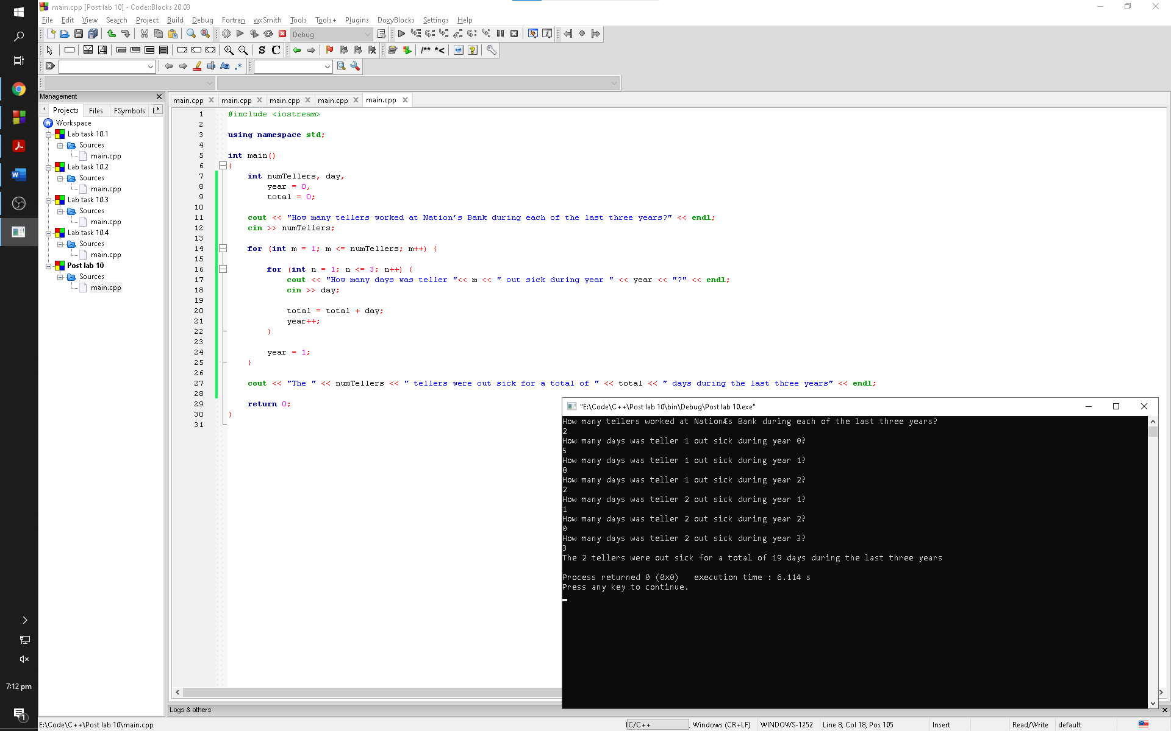

Observation: The program asks the user to enter the number of tellers to be used in the for loop. The program then loops around in the second for loop until 3 times. Once it is out of the first loop, the program prompts the user with the cout statement and aborts itself